BIT 4107 – Mobile Application Development
ENHANCED PROFESSIONAL STUDENT LOGBOOK
Student Name: GRACE MUINDI
Admission Number: BIT/2024/59311
School/Faculty: SCHOOL OF COMPUTING AND INFORMATICS
Programme: INFORMATION TECHNOLOGY
Academic Year: YEAR THREE
Semester: SEMESTER TWO
Lecturer: MR MICHAEL NYORO
Phone Number:

Week 1: Introduction to Mobile Application Development

1.1: Practical Activities Undertaken (SCREENSHOTS)
1. Installation of Visual Studio Code (VS Code)
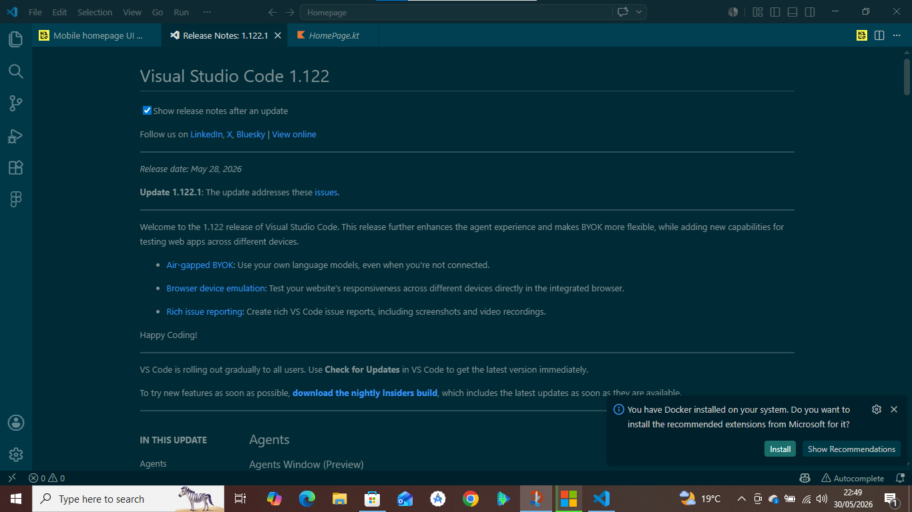
2. Installing Flutter and Dart Extensions in VS Code
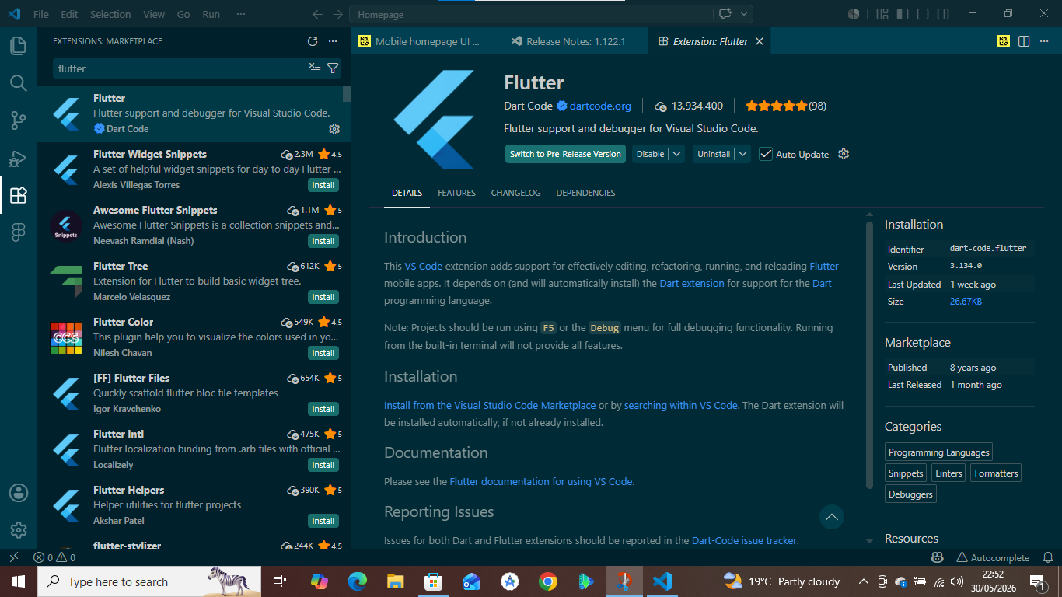
3. Verifying the Development Environment using Flutter Doctor
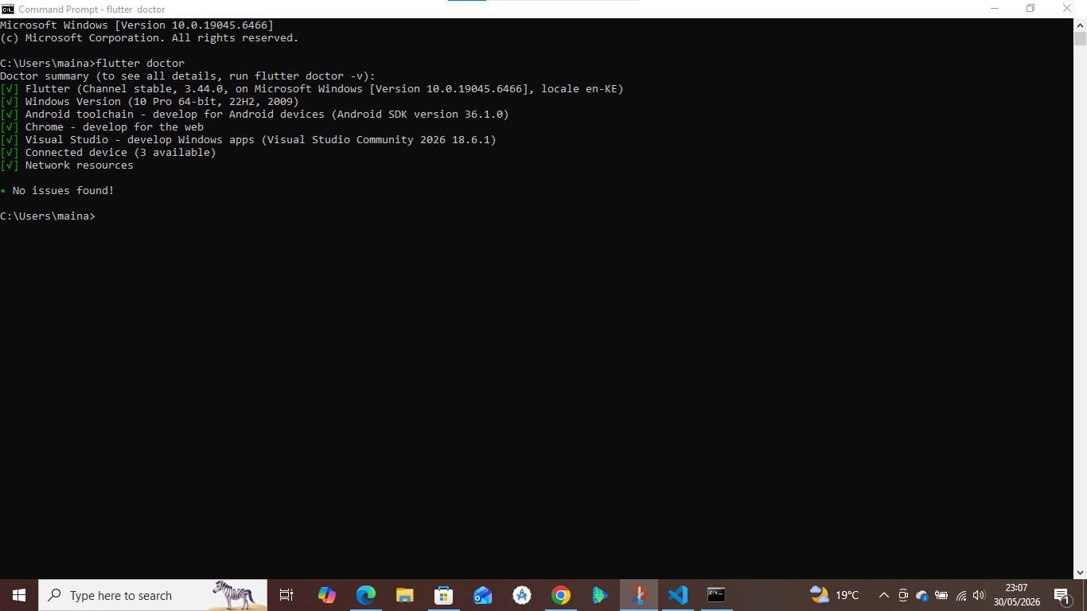
4. Creating the Flutter Project in Vs Code
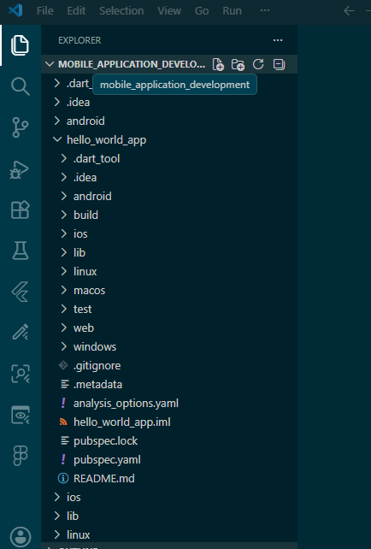

5. Source code of the flutter project
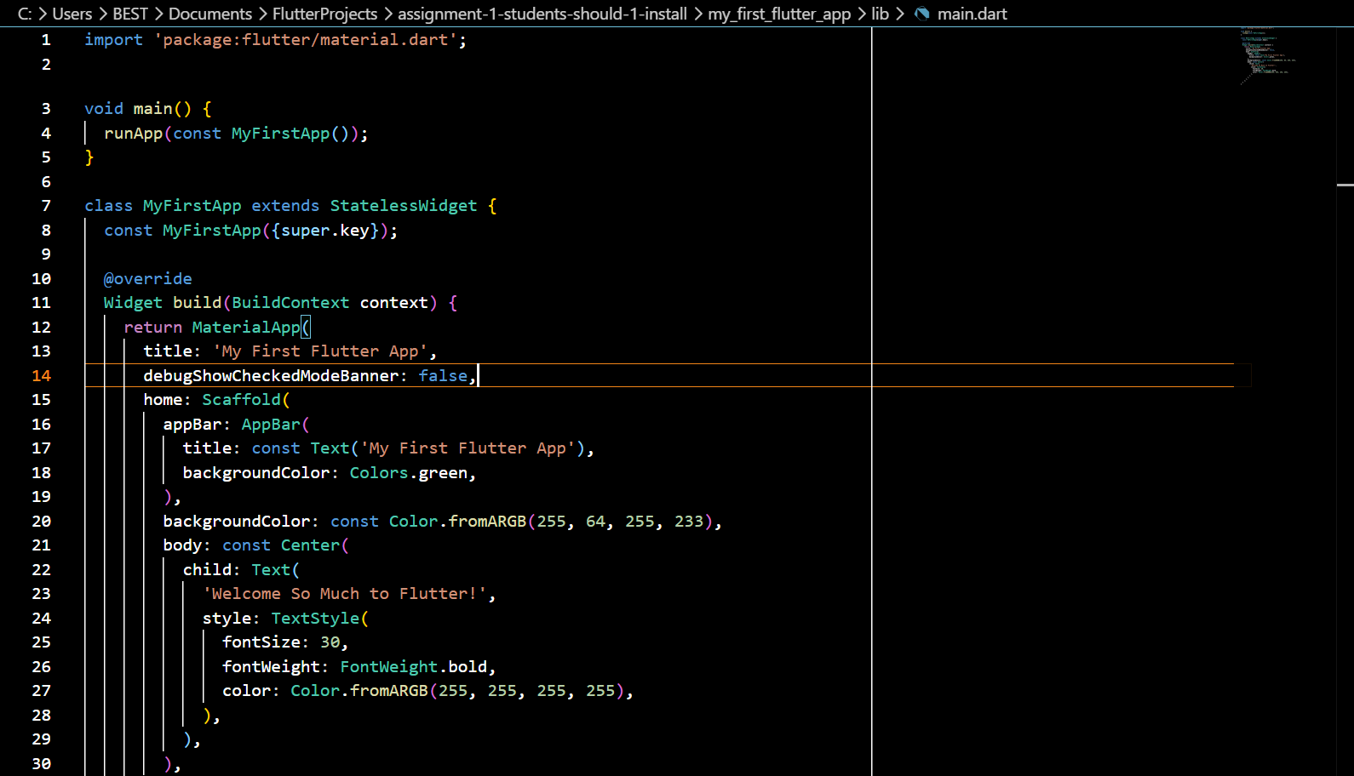
6. Running the Application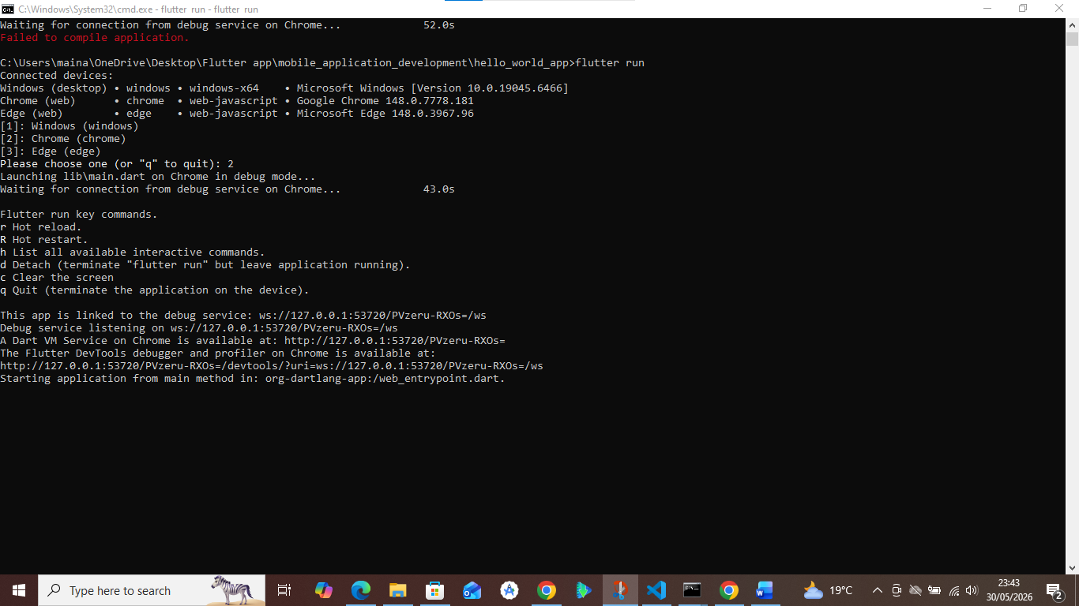
7. Final Outcome
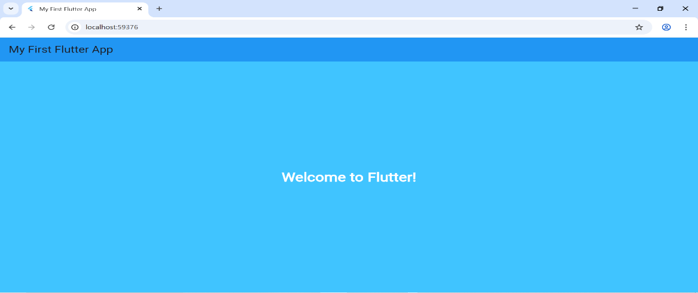

1.2: Tools/Software Used
The software is flutter extension inside VS Code Software.

1.3: Personal Reflection
Personally creating my welcome flutter app, I got to understand how to prompt flutter create a new project giving me the dependencies I needed in order to run the app via the edge or windows or chrome. It reminded me that every big journey starts with small steps. This milestone motivates me to keep learning, experimenting, and building more creative projects with Flutter.

Week 2: Mobile Development Environment

2.1: Practical Activities Undertaken (SCREENSHOTS)
1.Registration Screenshot
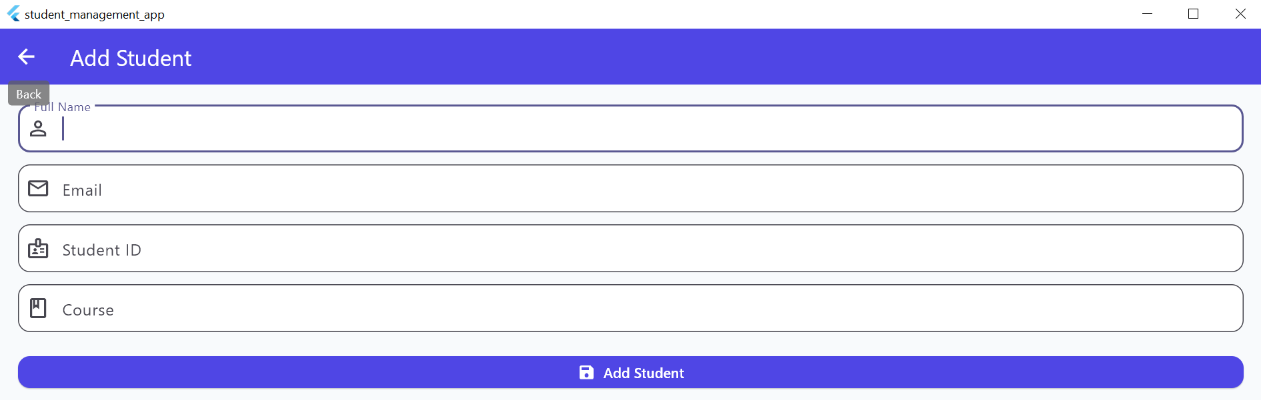
2: Login Screenshot
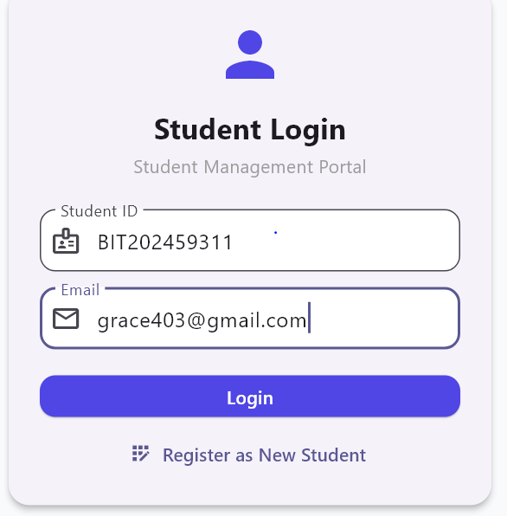
3.Dashboard Screenshot
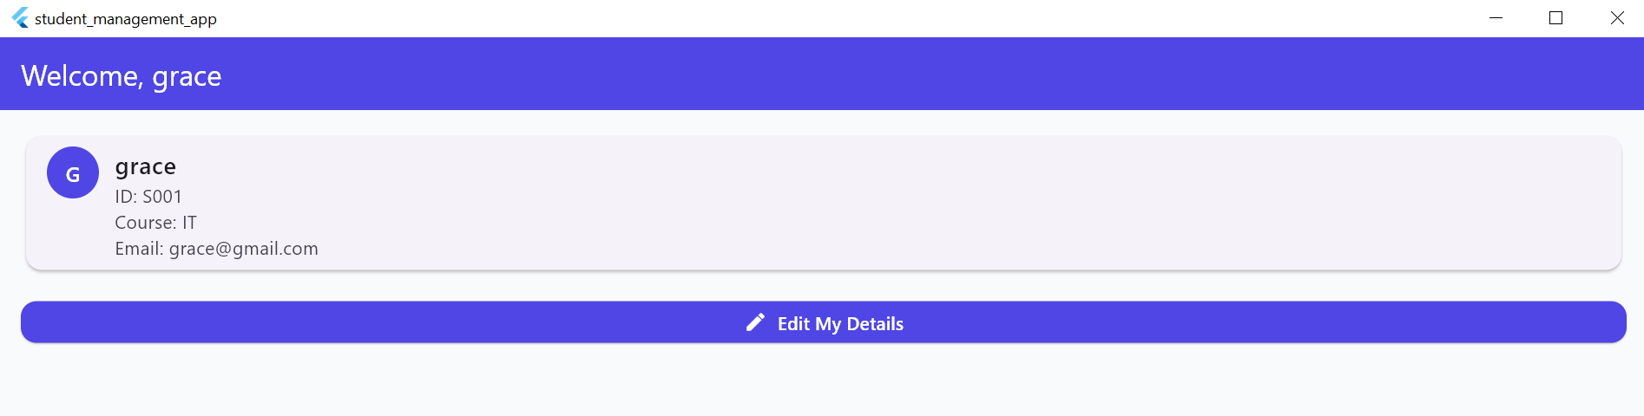

2.2: Tools/Software Used
Flutter extension and VS code were only used here.

2.3: Personal Reflection
Creating a school management app in Flutter challenged me to think like both a developer and an educator. Structuring student records, attendance, and grades taught me the value of clean data models. I learned that real-world apps demand more than working code — they require intuitive design that serves actual users like teachers and parents.

Week 3: User Interface Design

3.1: Practical Activities Undertaken (SCREENSHOTS)
1: Home screen
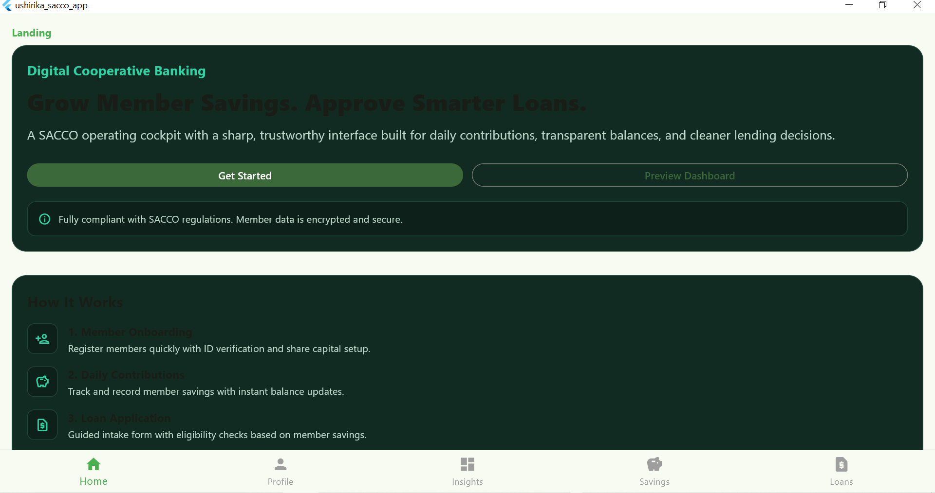

2: Profile Screen
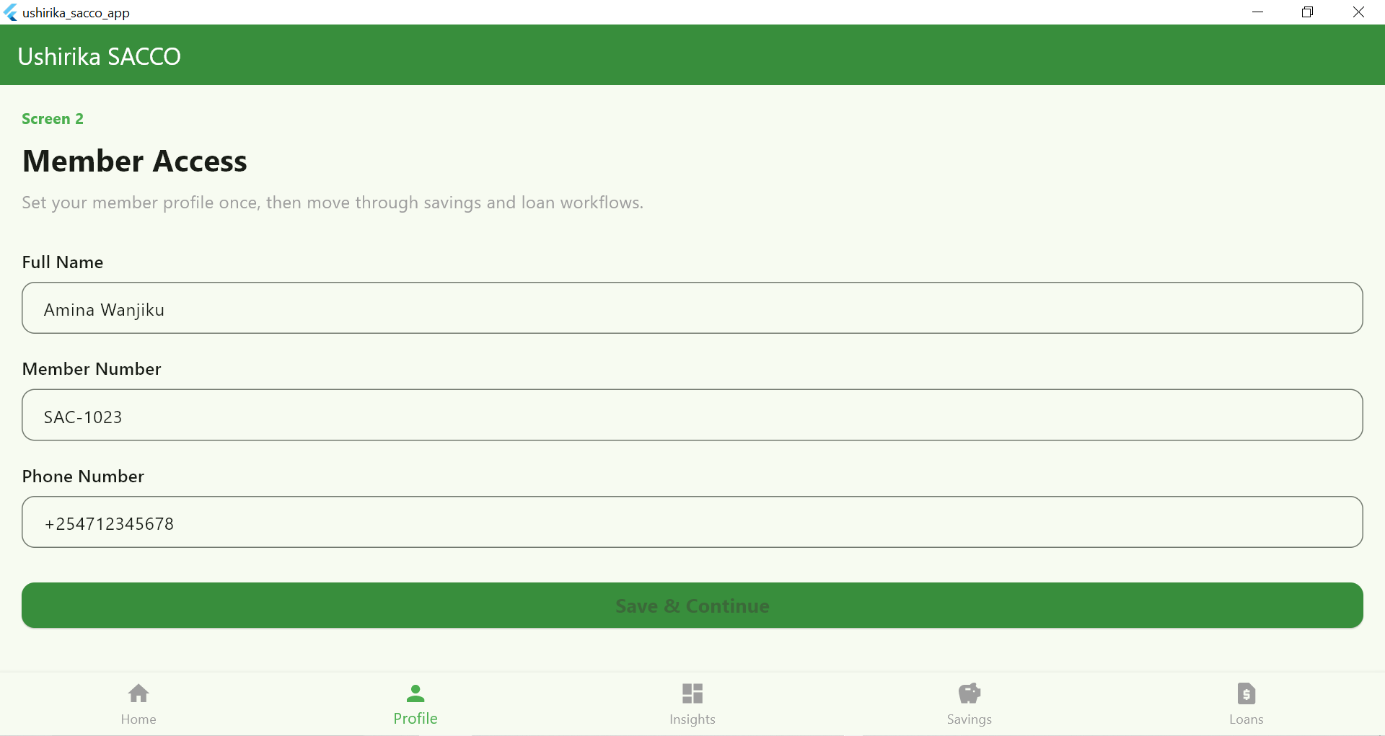

3: Insights screen
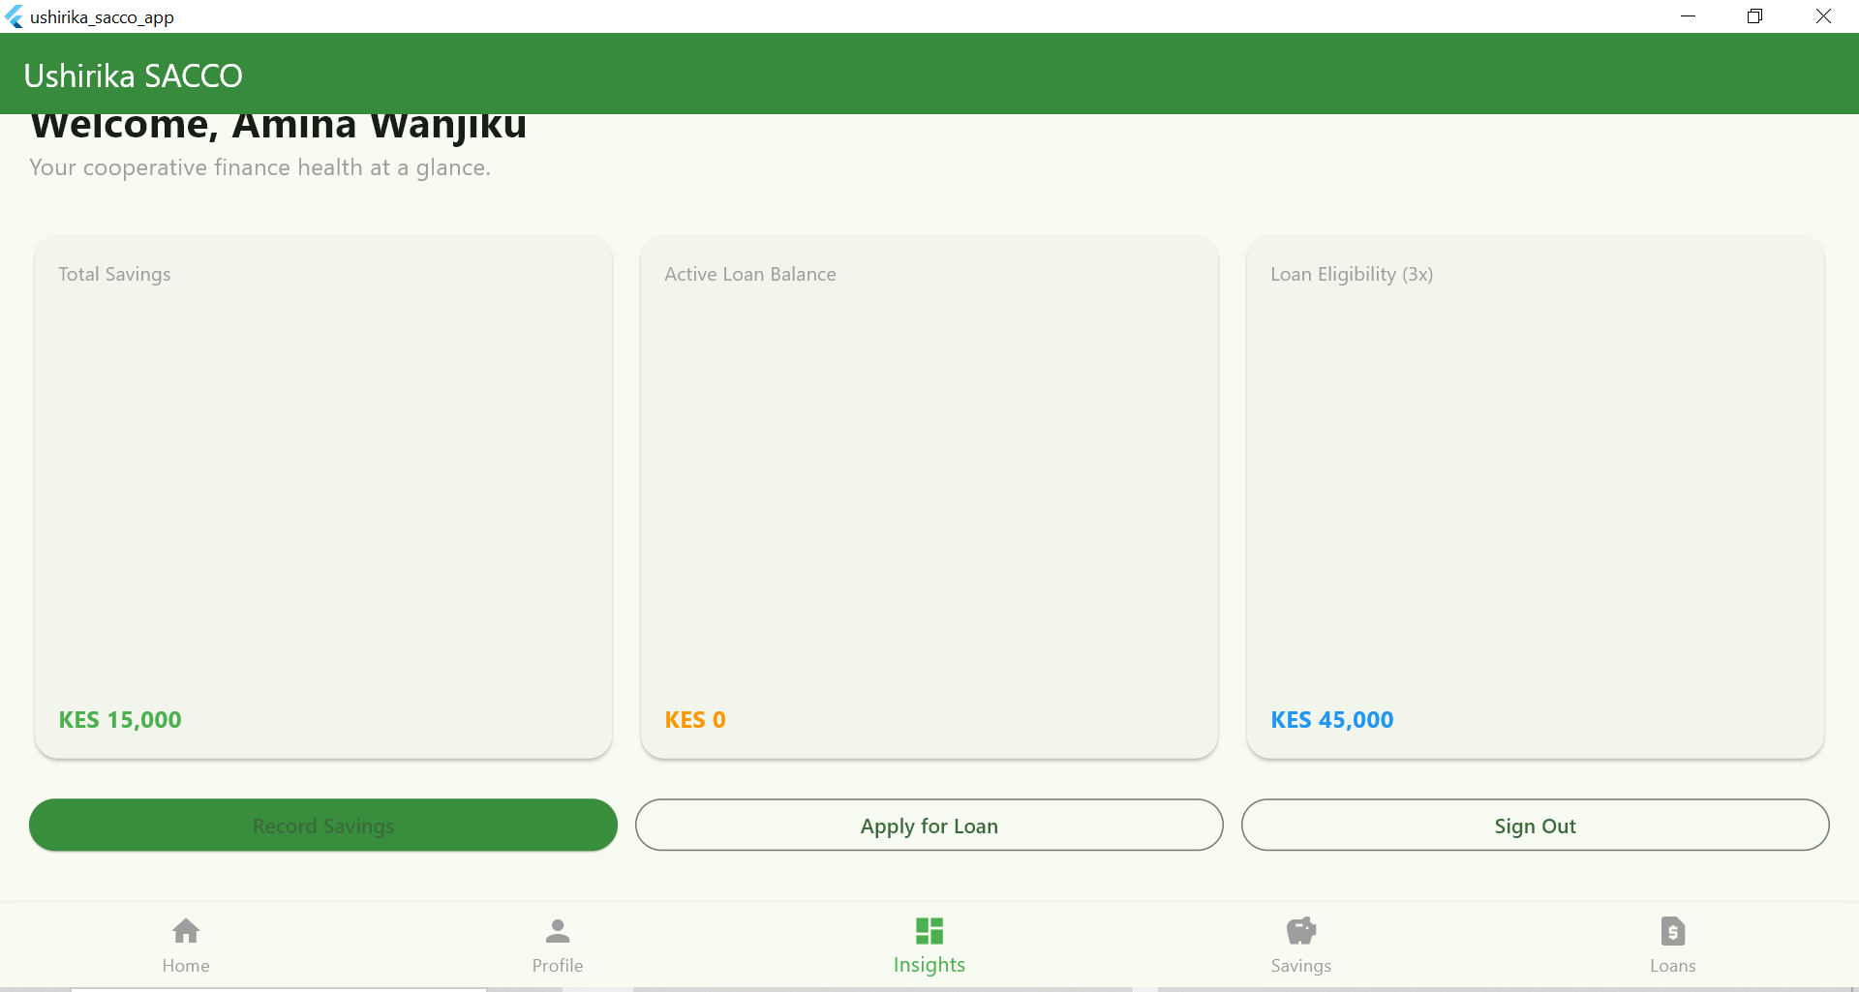

4: Savings Screen
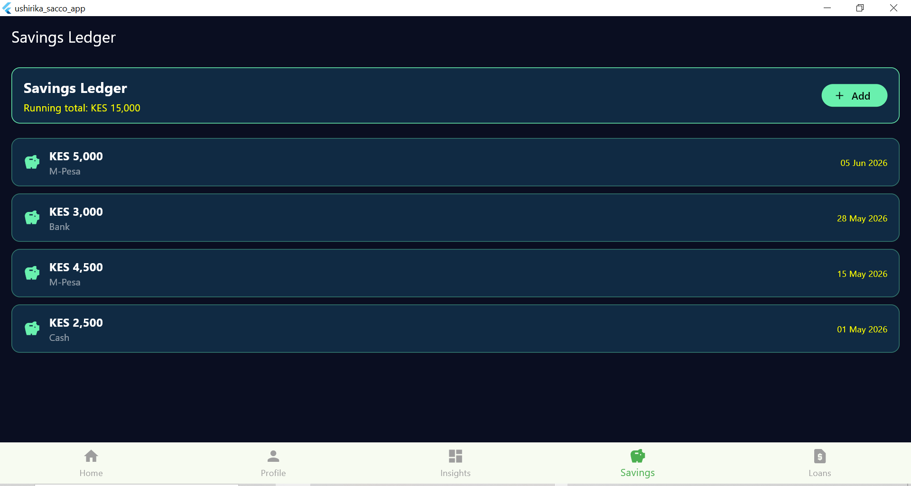

5: Loans Screen
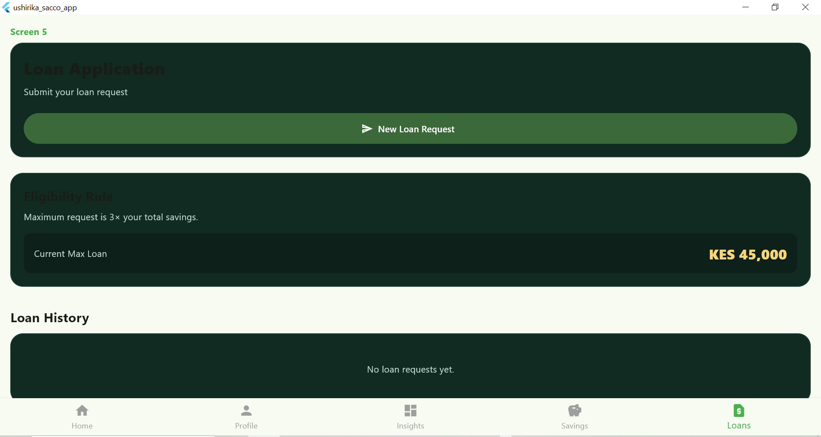

3.2: Tools/Software Used
Tools used are Figma and VS code. I used Figma to design the app and VS code to be able to deploy it and run it via android/iOS or via web or windows. The Vs code brings the design to actualization and to life.

3.3: Personal Reflection
Building the Ushirika SACCO app deepened my understanding of Flutter's design and dependencies, state management, and modular code architecture. Debugging import errors and missing dependencies taught me the importance of clean project structure. Integrating real-world financial logic savings tracking and loan eligibility made the experience both challenging and practically rewarding.

